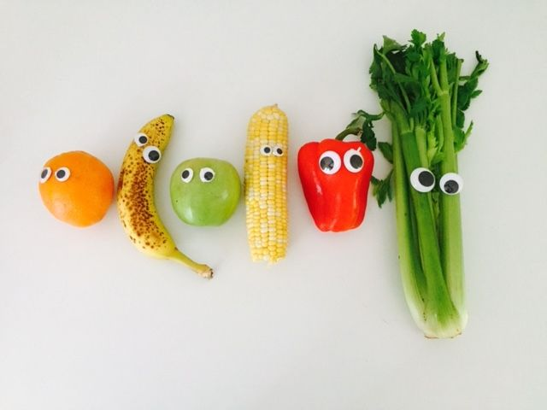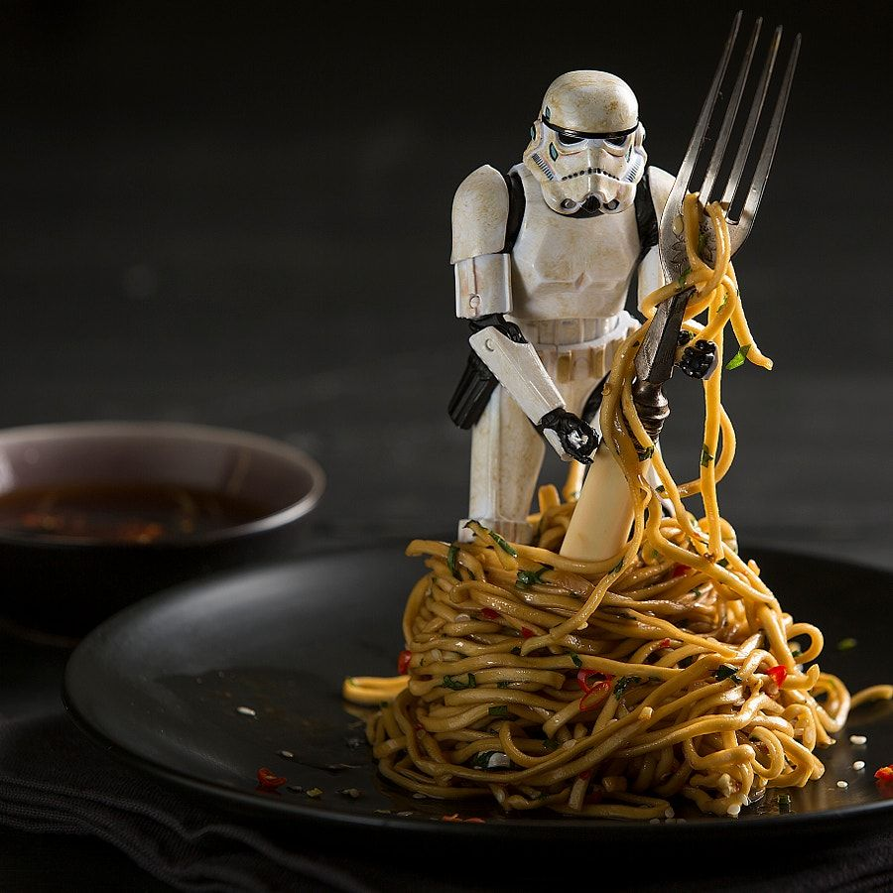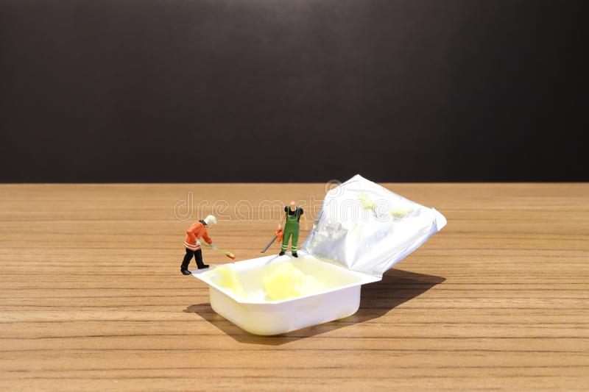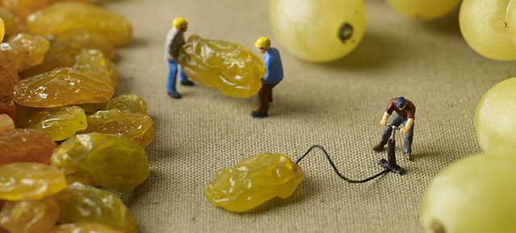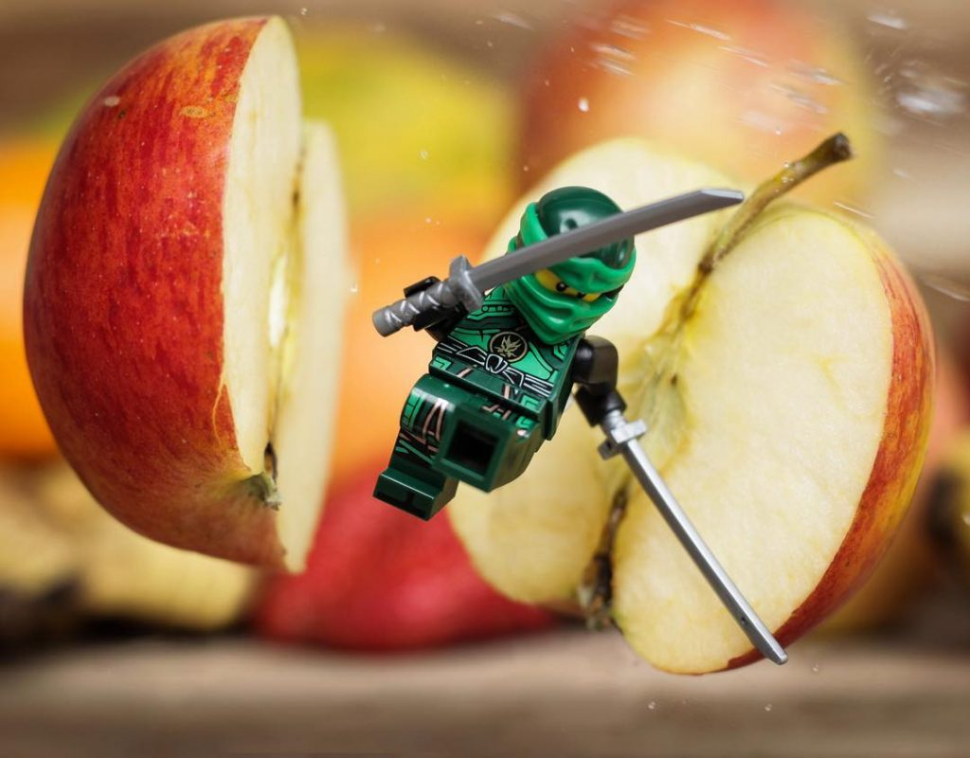

Your siblings might enjoy doing this too!

Task : Look around your home for mini figures of any kind – lego, playmobil, anything! Photograph them with your phone in interesting ways performing actions with food or food packaging. Make sure they are actually DOING something that the viewer will understand. You could do individual scenes or do a series of photos that tell a story. If you don’t have any figures you could draw some or cut some from a magazine.

Extra Task: If you have any craft googly eyes you could make some fun photos by sticking them onto food or cups, plates, spoons etc to make characters. There is a sheet of eyes provided if you don’t have any, or you could cut some from a magazine and use blu tac or tape.

YEAR 8 FOOD ART PROJECT PART 4: FUN PHOTOGRAHY