Book / Film review Writing Homework

Year 8
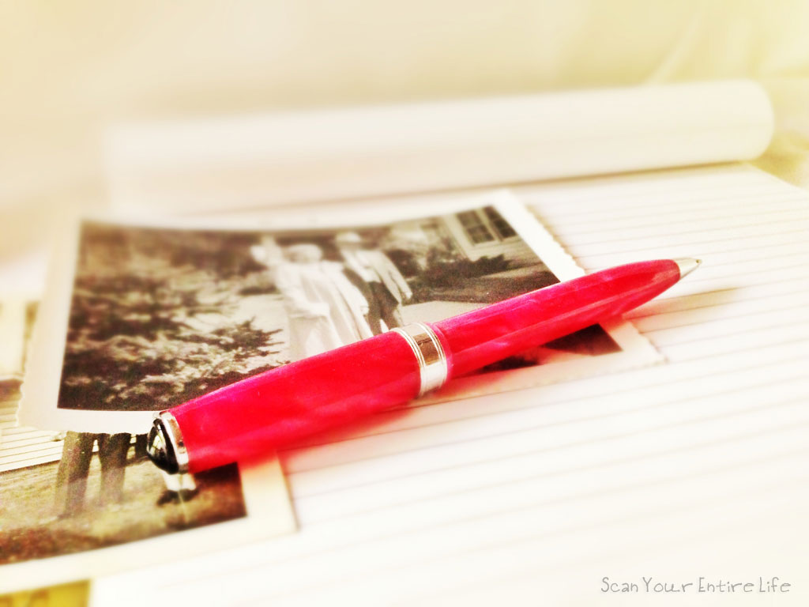

6 week project

This term, you will be working on a writing project for your homework tasks.
At the end of the project you will have drafted, edited and completed your own book or film review.

You will be aiming to develop the following skills:

- Writing for an audience
- Using engaging and ambitious vocabulary
- Punctuating for effect
- Creating effective tone and style
- Drafting and editing

KEY WORDS

Purpose: the reason something is done or created
Audience: the people who watch, read or listen to a book or film
Synonym: a word that has a similar meaning to another word
Protagonist: the main character in a book or film

Week 1. Before we start thinking about how to write a review, we need to understand what it is! Research and answer the following questions:

- Look up a definition of the word review, and write it below:

- Make a list of different places you might find a book or film review:

- What is the purpose of a review? (Think about the places you find a review). Write a paragraph explaining your thoughts.

- Find and print / cut out a review of a book or film. Attach it to this sheet.

- Completed

Week 2. Task 1: Look at the book review below. Highlight / underline and label the following features: Title, celebrity endorsement, quote from the book, exclamative sentence, rhetorical question, x4 adjectives.
CHALLENGE: What other language or structure features can you find?

Matilda by Roald Dahl – from the Penguin books website
"A true genius . . . Roald Dahl is my hero" - David Walliams
"So Matilda's strong young mind continued to grow, nurtured by the voices of all those authors who had sent their books out into the world like ships on the sea. These books gave Matilda a hopeful and comforting message: You are not alone."
Matilda is the world's most famous bookworm, no thanks to her ghastly parents. Her father thinks she's a little scab. Her mother spends all afternoon playing bingo. And her headmistress, Miss Trunchbull? She's the worst of all. She's a big bully, who thinks all her pupils are rotten and locks them in the dreaded Chokey.
Despite these beastly grownups trying to push her down, Matilda is an extraordinary girl with a magical mind.
And she's had enough.
So all the terrible adults had better watch out, because she's going to teach them a lesson they'll never forget!

Task 2: Which of the features you have found is the most effective at persuading you to read the book? Write a paragraph explaining your answer using an example.

- Completed
Week 3. One of the purposes of a review is to convince the audience to read the book, or watch the film. This is achieved using persuasive language.
Task 1. For each of the words below, write down two synonyms that are more effectively persuasive:

Task 2. Read the review below.
I think the Hunger Games books by Suzanne Collins are very good. The main caracter, Katniss, is a brave and clever girl, who stands up for her freinds and family. The Hunger Games are a series of difficult challenges that Katniss has to overcome to survive. Their are several times during the books when Katniss risks her life, but I think this adds to the exicitment. You should read these books if you enjoy adventurous and interesting stories.

Re-write the review, correcting the spelling mistakes (underlined) and improving the persuasive language (highlighted):

- Completed
Week 4. Read the review of the film ‘The Meg’ on the next page, and then answer the following questions:

Q1. What is the name of the protagonist who is described in the first paragraph?

Q2a. In paragraph one, find a word that describes the behaviour of the marine crew

Q2b. In paragraph one, find a word that describes the appearance of one of the team members.

Q3. Would you describe the tone of this review ‘formal’ or ‘informal’? Write a brief paragraph explaining your answer, using an example from the text.

Q4. Does this review persuade you to go and see this film? Write a brief paragraph explaining your answer, using an example from the text.

- Completed

The Meg’ Review: The Summer’s Guiltiest Pleasure Stars Jason Statham and a Giant Prehistoric Shark

Statham does what he can to salvage this cartoonish marine showdown, but director Jon Turteltaub can't resolve two very different tones.

In “The Meg,” Statham plays disgraced deep-sea rescue diver Jonas, called back to action after an undersea observation program leads to a submersible getting trapped at the bottom of the ocean, where a clearly hungry, 75-foot megalodon circles. In short order, the operation brings the creature back up with it, and Statham spends much of the movie alongside an anxious marine crew concocting new ideas for killing it — mostly on his own, diving into the water more than once to take the beast on up close.
At one point, when Jonas leaps into another battle with the meg, the movie comes pretty close to breaking the fourth wall. There’s a brief pause, and one of the team members (a dishevelled Rainn Wilson) belts out, “Hell yeah!” He speaks for all of us. When Statham and his foe tussle up close, Turteltaub delivers the summer’s guiltiest pleasure.
And yet nothing in “The Meg” can keep pace with the underlying appeal of those recurring fights. The movie has been populated with an international cast clearly designed to enhance the global box office potential, but it often leads to actors delivering weak line readings in second languages. The English itself often sounds as though it’s been boiled down to the lowest common denominator, to the point where you could watch “The Meg” as a silent film and get the gist.
Still, the screenplay provides a handful of endearing characters, including Wilson’s smarmy overseer, and marine biologist Suyin (Lin Bingbing), who provides Statham with a partner in crime and a love interest. In a few scenes, the pair almost generate bonafide chemistry, and of course it’s refreshing to see a blockbuster with an interracial couple that doesn’t waste time overplaying it. They’re just a natural fit.

Ultimately, though, “The Meg” belongs to the monster of the title. Decades after “Jaws” turned the conceit of a water-bound carnivore into pure horror based on what you don’t see, “The Meg” falls in step with today’s CGI-laden obsessions by letting it all hang out. The shark — or is it sharks? — snaps its massive jaws and dives through the air as if its animation designs only included two modes. That’s all well and good in a pitch-black gag that finds it massacring a color-coded beach filled with oblivious partiers, but the movie fails to reconcile its cheekiness with the bonafide sci-fi survival tropes that enshroud the scenes on the ship.

Ultimately, “The Meg” suffers from comparisons two superior comparisons. Alexandre Aja’s brilliant B-movie excursion “Piranha 3D” transformed the horror movie premise of the original into a live action comic book that flaunted outrageous genre tropes like a firecracker; Turteltaub never gains such confidence in the material to let it go all-out bonkers.And then there’s Shark Week. “Haven’t you guys ever seen ‘Shark Week’?” Wilson’s character asks the crew as they talk through ideas for tracking their marine assailant. “The Meg” makes a pretty good case for why we should: Statham remains an appealing summer movie fixture, but sharks deserve better than this.

Week 5. You are going to write a detailed review. Your review should include a paragraph on each of the following:

- A summary of the plot
- A description of the main character(s)
- Your opinion – how good is it?
- Your opinion – what doesn’t work / would you change?
- A conclusion

Use the notes below before you start.
Name of book/tv/film__________________________________________________________
Where your review will be seen (e.g. school library, children’s magazine, advert in a newspaper) ___________________________________________________________________
Who is the ‘audience’ for your review? Who will be reading it? ___________________________________________________________________
Now, making sure your writing is aimed at the audience you’ve chosen, write your review.

- Completed
Week 6.
TASK 1. Edit your review USING A DIFFERENT COLOUR PEN. Use these EBIs to help you:

- Check your basic punctuation. Have you used capitals, full stops and commas?
- Now consider where you might punctuate for effect. Can you use punctuation to change the pace or add emphasis? Have you used a range of sentence structures for clarity and effect?
- Have you used the most persuasive language? Specifically check adjectives and adverbs to make sure they are powerful and engaging. How about using a rhetorical question?
- Check the FLOW of your work. Read it out loud – does it make sense? Are there ‘clunky’ phrases that you can improve.

CHALLENGE: Can you add humour to your review to give it more impact?

TASK 2: Write up the final draft of your review on lined paper and give it a catchy title.

- Completed
Extra tasks

- Create a book cover / film poster to advertise your book or film

- Visit the website below and look at a multi-media film review. Then review the review! Write one or two paragraphs on how persuasive the review is, with examples. Is a Youtube review more persuasive than a written review? Why?
https://www.youtube.com/watch?v=i9R9L0iLPTM

- Visit the Library and choose a picture book to review. Write a short review to persuade a 6 year old to read the book, and a short review for the same book for their parent. Evaluate your work – how are the 2 reviews different? What have you changed to appeal to the different audiences? Write a paragraph explaining how the two reviews differ.

Extension / development ideas
- Structure: Does your review have an engaging ‘hook’ and conclusion? First impressions are formed at the very beginning of texts, so make sure the beginning catches the reader’s attention.
- Devices: Can you showcase a range of descriptive devices in your writing? Simile; metaphor; personification; onomatopoeia; and alliteration can all make your writing more-engaging to read.
- Sentence structure: Have you varied your sentence structures and sentence lengths? Short sentences can be used for impact and effect.

