Marketing Project

Name Class

Teacher Feedback
Comment(s):
Effort:
Presentation:
Progress:

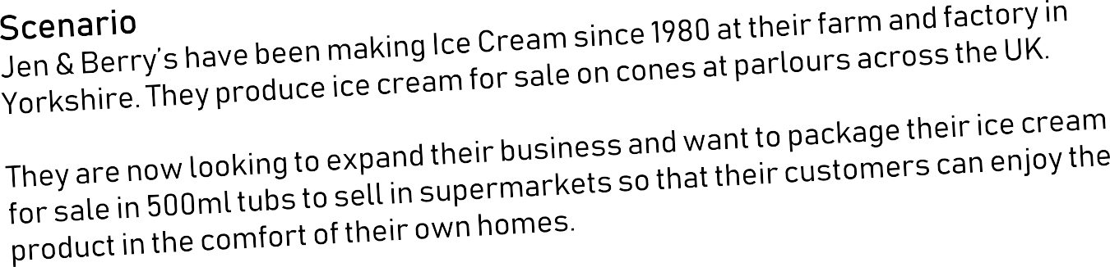

Market Research
Before businesses make a new product, they often take time to find out what people want or . This is called Market .

Businesses can choose to gather their own research data (by carrying out their own , for example), or use data and information that already exists (by carrying out research on the Internet, for example). Gathering your own data or is called Primary Research and is more time consuming than using data that already exists. It can also be more . This research also means that your business’s research isn’t shared with any of your .

Looking at and using data that already exists is called Research. This is less expensive and usually , but might not fully suit your business’s needs.
Words to use:
research | competitors | expensive | questionnaires
information | need | secondary | quicker

Questionnaire

What I want to find out…

Questionnaire

Your questionnaire should:
- Fit on one A4 page
- Have space for all the responses you want to gather (you are only printing one!)

Glue your questionnaire here

Target Market / Customer Profiles
- 4 -

Customer Profile | Product(s) & Reasons
Layla, busy Mum who buys ice cream as a treat for her four young children (all under 10).
Jonathan, professional 30 year old who enjoys ice cream at home whilst watching films.
Damion, a student on a budget who buys ice cream on his way home from school.

Your Customer Profile

Focus Group

Question(s) | Responses / Feedback

Interview

Questions | Responses

Competitors

Jen & Berry’s
Competitors

Initial Product Ideas
Idea A Idea B

Idea C Idea D

Self-Assessment

Favourite Design | Good Points | Improvements

Peer-Assessment

Favourite Design | Good Points | Improvements

Chosen Design | How I will improve it (and why)?

Final Product Design

Final Product Decisions

Price
Product
Place
Promotion
Packaging

Pricing Strategies

Competitive Pricing  This is when businesses look at what their competitors charge before deciding on a price point. It is not always necessarily a cheaper price they decide to charge though. | Psychological Pricing  Businesses often avoid round numbers when pricing their products. Instead of £1.00, lots of businesses charge 99p instead. This is called Psychological Pricing, where businesses try to make their prices appear that little bit  more affordable.
Price Skimming  When launched, some products are priced high before being reduced at a later date. This is called price skimming and is often for ‘in demand’ products. | Price Penetration  It can be difficult to get customers to change their habits when they’re used to buying certain products. Charging a low price to encourage sales and increasing it later is called Price Penetration.

In the first month, Jen and Berry’s new 500ml Ice Cream tubs will be sold in one supermarket local to the farm.

What price will you charge per 500ml tub of Ice Cream?

- What pricing strategy will you use? Why?

- How many tubs of Ice Cream do you think you will sell in the first month of launching? Why?

- Calculate your revenue for the first month of sales. Show your working out.

- Each tub will cost you £0.55 to produce. Calculate your costs AND profit for the first month of sales.

© BP 2019

- 12 -

