How do individuals develop across the life stages  Year 9 - Workbook | Explore Human Growth and Development across life stages.  Learners will begin to create individual BOOKS / INFORMATION to show key aspects of human growth and development at each life stage.  Teacher: M SAYEED

Key Words
Growth

Development 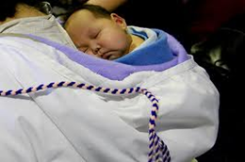

Life-stage

Lifespan 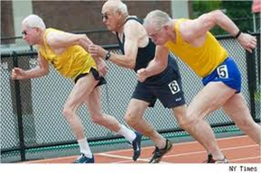

Developmental Norms

PIES

Growth and Development
What is growth?
- means an increase in physical size.
What is development?
- means an increase in skills, abilities and emotions.
What is life stage?
- is a defined period of growth and development
What is lifespan?
- is the time between a person’s birth and his/her death.
What are developmental norms?
- The ways in which people grow and develop tend to follow a pattern.

Unit Content
Have a discussion with a person (perhaps a friend or family member) and write down as many things as you can that you think you may cover in this Unit.

Exercise / Word-storm Ideas.

Growth and Development Continued

The growth and development “milestones” (learning to sit, walk and talk for example) and the points in a person’s life when they happen are commonly referred to as developmental norms.

During our life span there are different life stages we go through.
What ages do you think are covered in the following stages?

(Individual or Group Task)

- Conception to birth
- Infancy
- Early childhood
- Adolescence
- Early adulthood
- Middle adulthood
- Later adulthood

Answers - During our life span there are different life stages we go through.

- Conception to birth
- Infancy 0-2 years
- Early childhood 3-8 years
- Adolescence 9-18 years
- Early adulthood 19-45 years
- Middle adulthood 46-65 years
- Later adulthood 65+ years

Exercise - What age and stage are these people in?
Explain why you have made your decision.
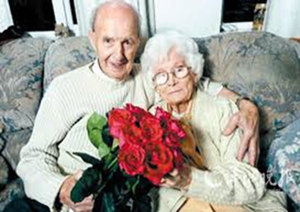
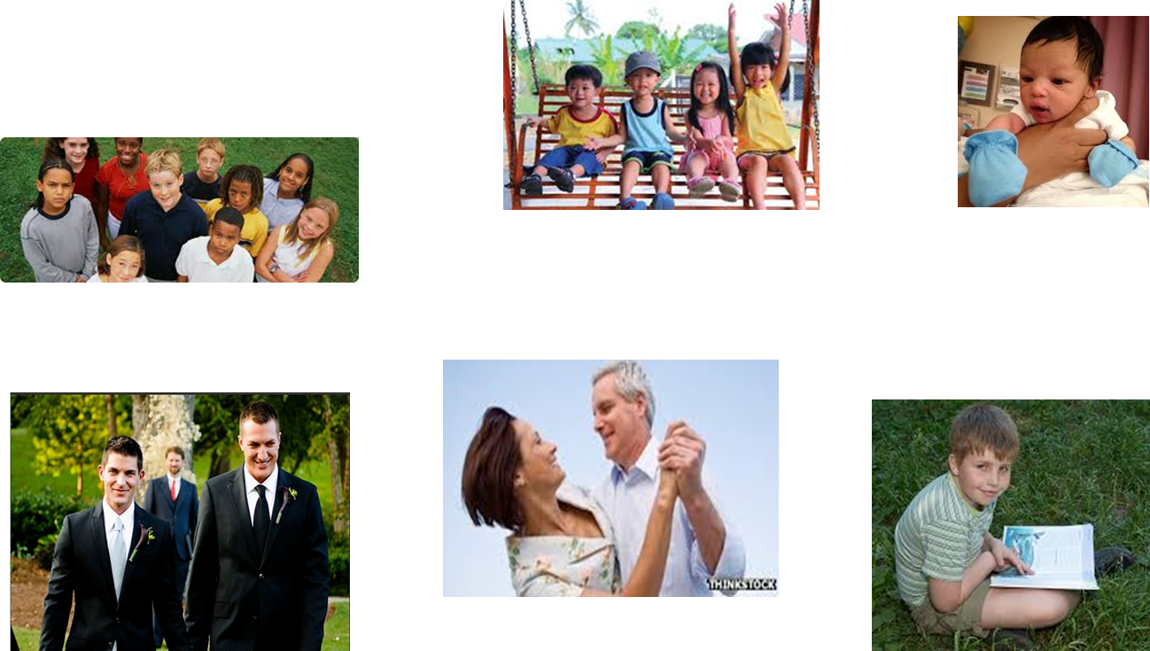

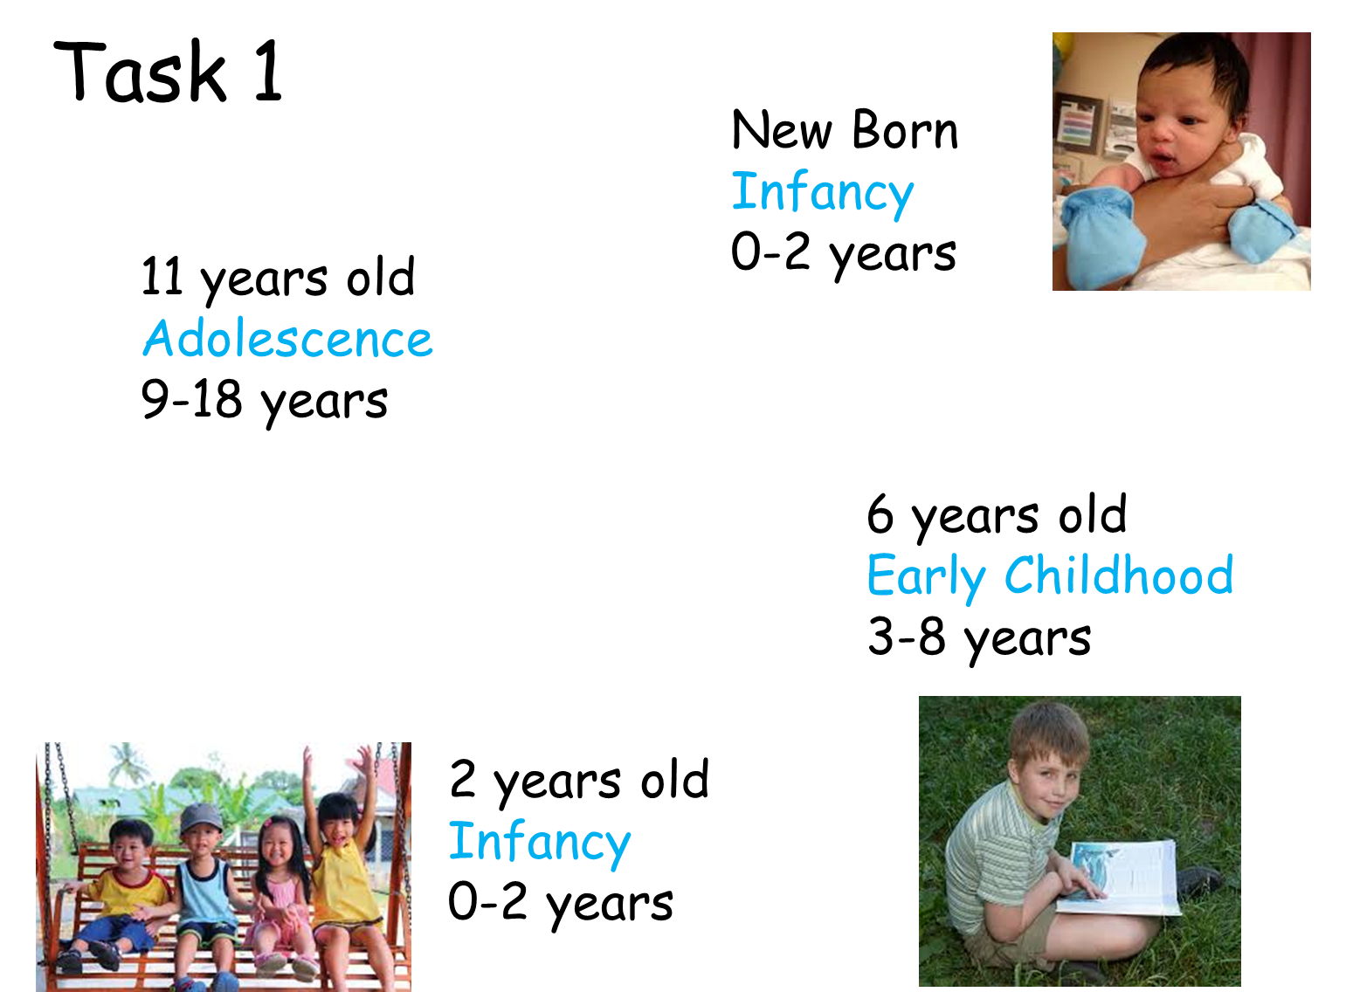
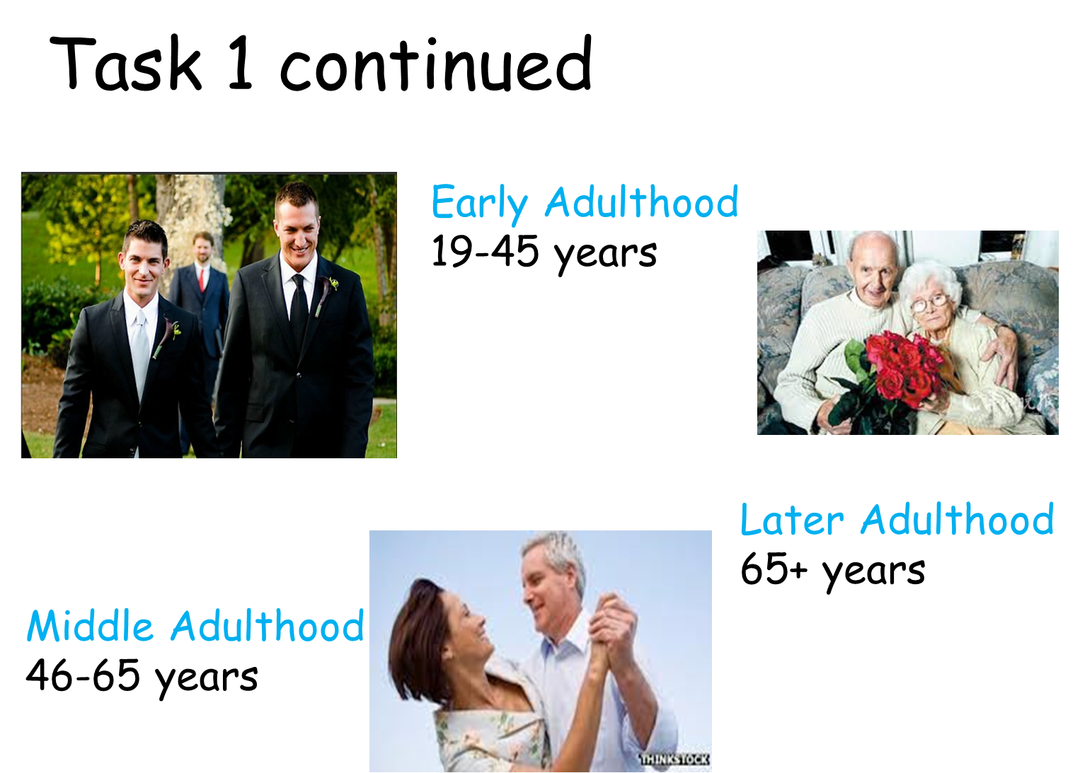
Exercise - What do PIES stand for in Health or Social Care?

P
I
E
S

What do PIES stand for in Health or Social Care?

Physical
Intellectual
Emotional
Social

How life begins?
Before we discuss how babies are made, we must understand how the female reproductive organs work.

Female Reproductive Organs

- Females have two ovaries which both contain thousands of eggs.
- About once a month, one egg(s) leaves the ovary and travels down the fallopian tube towards the uterus(womb). This is called ovulation.
- While the egg is developing and travelling the uterus starts preparing for it by building up its lining with extra blood and tissue (a bit like making a 'nest').
- If the egg is fertilised by a male sperm then the body will use that 'nest' to protect and nourish the egg as it grows into a baby.
- If the egg is not fertilised then it will keep going, passing through the vagina and taking with it the extra blood and tissue that wasn't needed. This is what is called a period or menstruation.

- A period usually lasts around 2 -7days. The egg is so tiny that you will not see it.
- About 7 – 10 days later another egg leaves the ovary and the whole thing starts again.
- This menstrual 'cycle' usually takes 28 days, but it can be longer or shorter.
- When you start your periods, they may not be very regular at first. (They may not happen every month or you may have a light then a heavy period.)
- Everyone is different.

PIES development in Childhood
Starter Activity - Human Growth and Development.

Words to Look For – Next Page.

Adolescence
Adulthood
Birth
Childhood
Conception
Development
Growth
Infancy
Lifespan
Life-stage
Menstrual
Norms
Ovulation
Reproduction

PIES development in Adolescence

Characteristics of Adolescence
- Period of life between 9-18 years
- Clear and definite physical changes occur

Secondary sexual characteristics develop (other than those of sexual organs)
Girls – develop at approx. 11 years who reach full reproductive capacity at around 18-19 years
Boys – achieve reproductive capacity at around 14 years but DON’T reach adult stature until several years later

- Build on independence without full adult responsibility

Physical changes

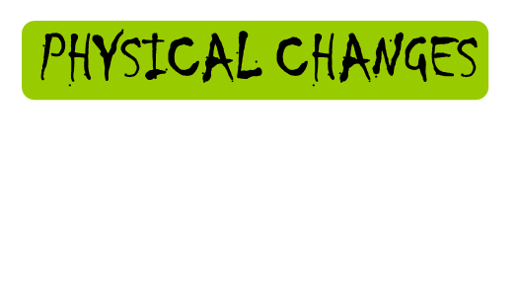

Self-Concept
increasingly Body Image
Affected by rapid growth
Shy, awkward and clumsy – new body!
Height change – can change communication channels/relationship with parents/adults
Erikson suggested a distrust of the body resulting from the sudden growth spurt
Bulimia and Anorexia nervosa considered to be Rejection of the ‘new body’ and the perception that it will make them less lovable and attractive
Uncomfortable with the image

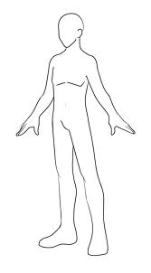
Look at the male body and label the Physical Changes that occur during Puberty.

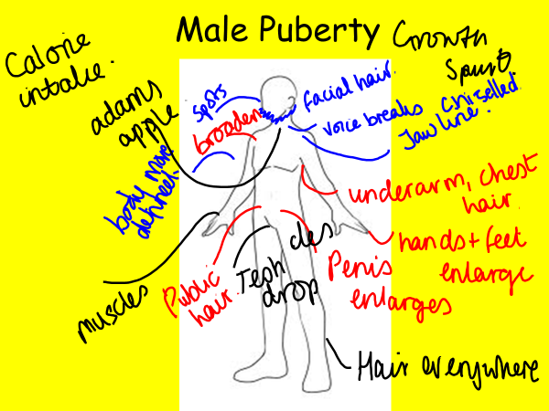

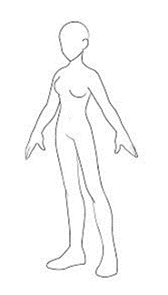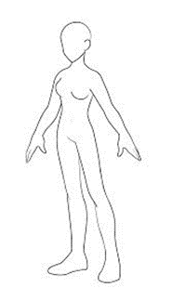
Look at the female body and label the Physical Changes that occur during Puberty.

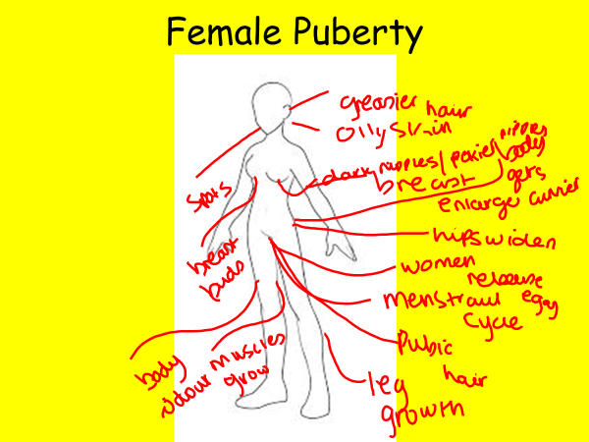

9 – 18 years
Intellectual Development

9 – 18 years
Emotional Development

9 – 18 years
Social Development

Exercise – Refer to Learner Book
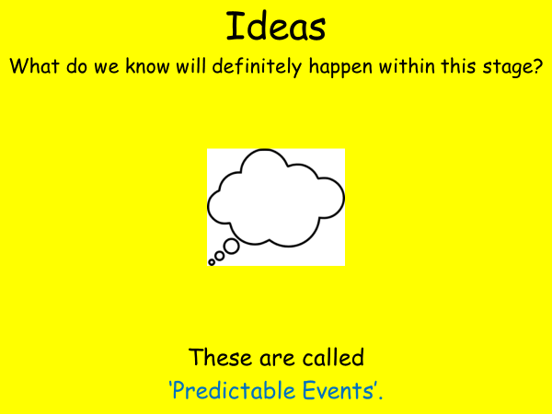

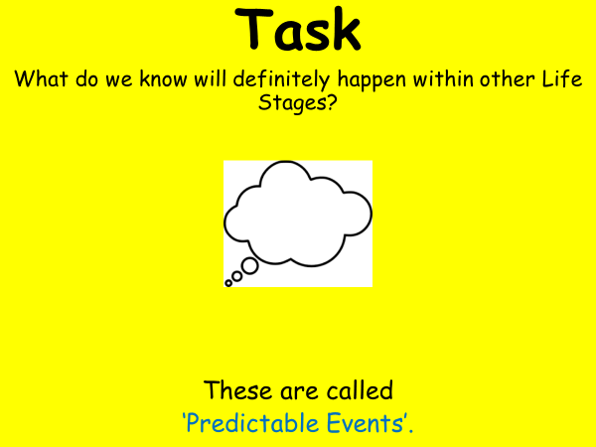
Development Tasks of Adolescence

Working individually…

Think about the kind of skills adolescents have to develop in order to successfully make the transition to adulthood.

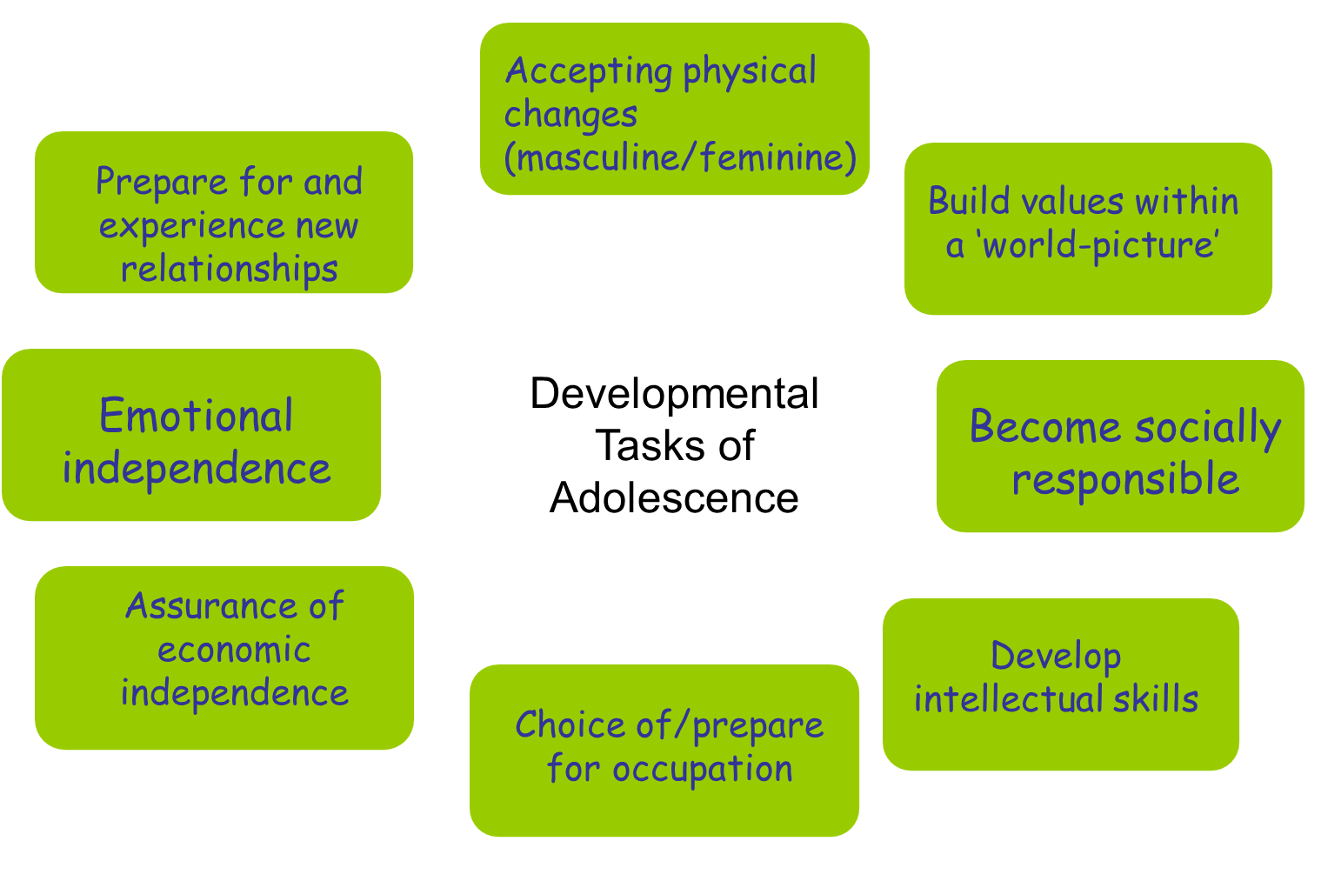

Physical Health Needs

Exercise - What does Physical Health mean to you?
Let’s see how many we can get.

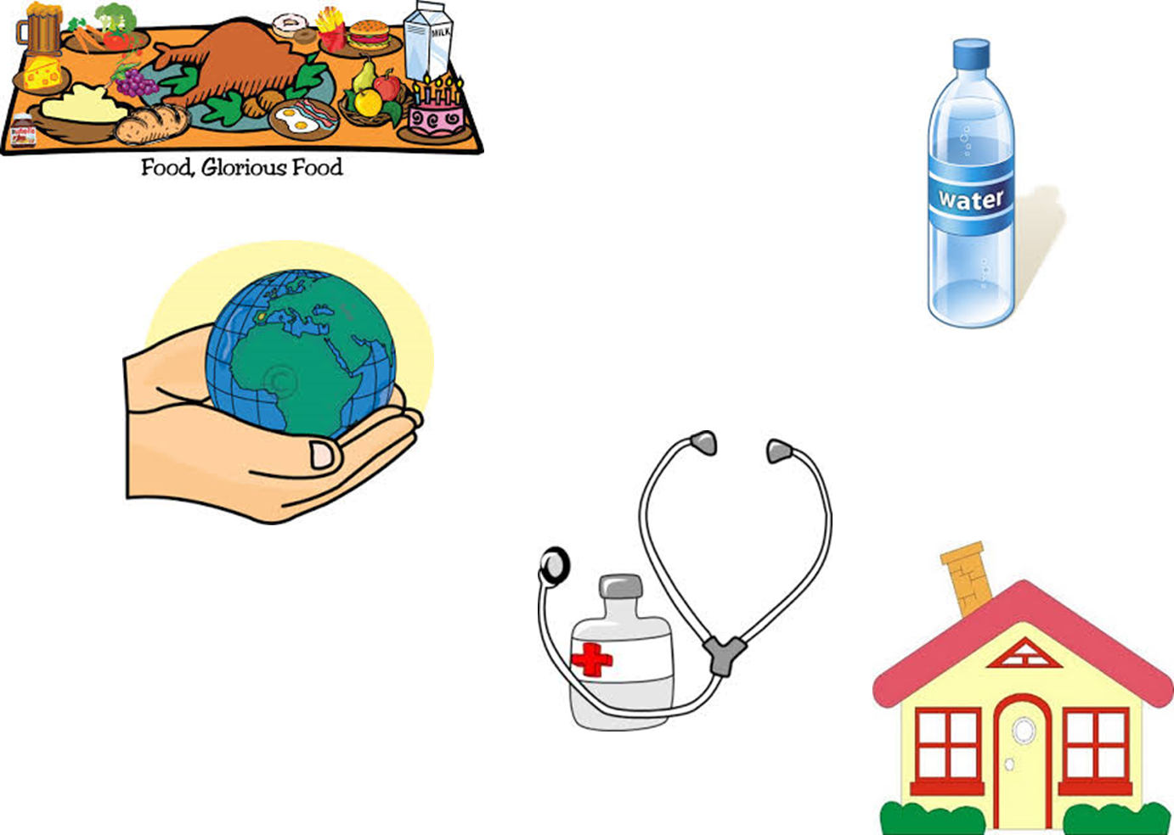

PIES development in Early Adulthood

Recap: During our life span what are different life stages we go through?
- early adulthood 19-45 years
- middle adulthood 46-64 years
- later adulthood 65+ years

Adulthood – Grown-up (19-64 years)

This area covers a wide range of change.
How many years are covered?
Approximately 45 years.
A lot can happen over 45 years.

In the last 45 years.
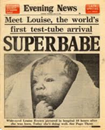1978- First test-tube baby is born in the U.K.
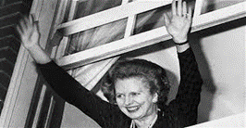1979- Margaret Thatcher (a woman) becomes British Prime Minister.
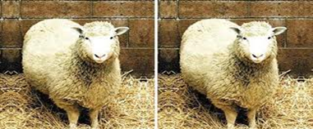1996-Dolly the sheep becomes the first mammal cloned from an adult cell (dies in 2003).
2001- American Airlines Flight 11 and United Airlines Flight 175 are flown into the World Trade Centre’s Twin Towers in New York.

Grown-ups or adulthood is often divided into two sections. What are they?

Think about the Following!

Early Adulthood. (19-45 years).
Middle Adulthood. (46-64 years).
What do we know will definitely happen within this stage?
These are called ‘Predictable Events’.
Is being an adult easy?

Physical Changes
Your Turn

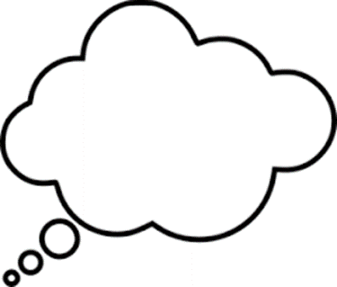
Can you:
- Go out when you like?
- Come in when you like?
- Spend money as you like?
- Go to bed when you like?
Come up with FIVE decisions you may be faced with in early / middle adulthood. (19-64 years).
Think about what could affect these decisions?

Major life events:
Differences in effect of predictable and unpredictable events; e.g. the birth of a sibling, leaving home, leaving care, leaving prison, serious injury, illness, starting school/nursery, beginning and
changing employment, redundancy, bereavement, marriage, parenthood, divorce; the interrelationship
between factors.

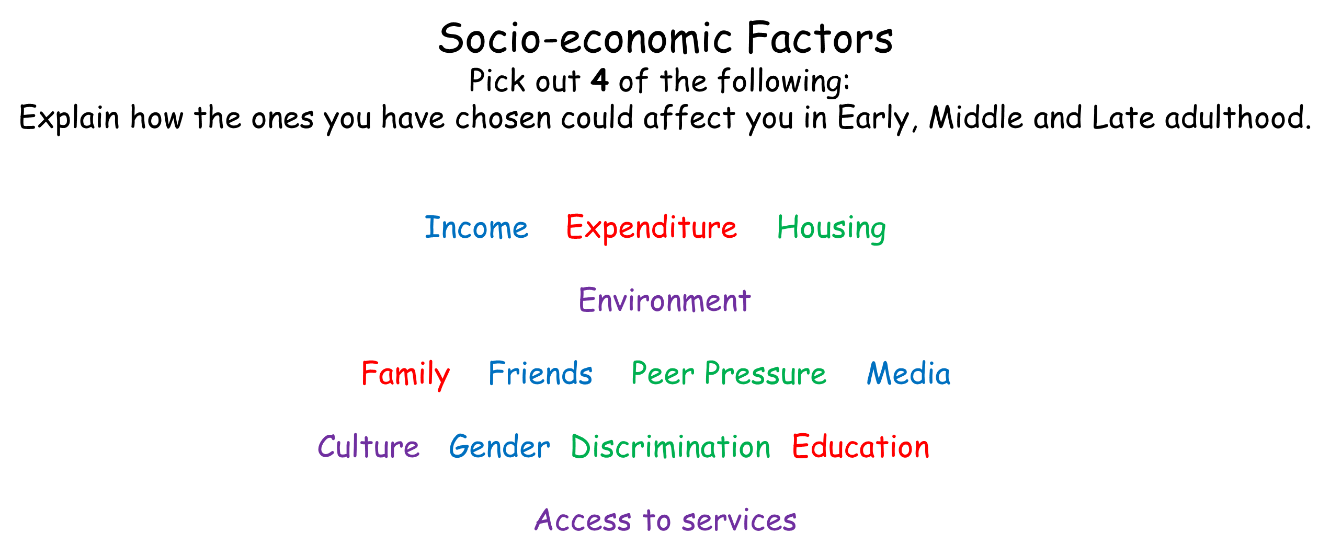

PIES development in Adulthood
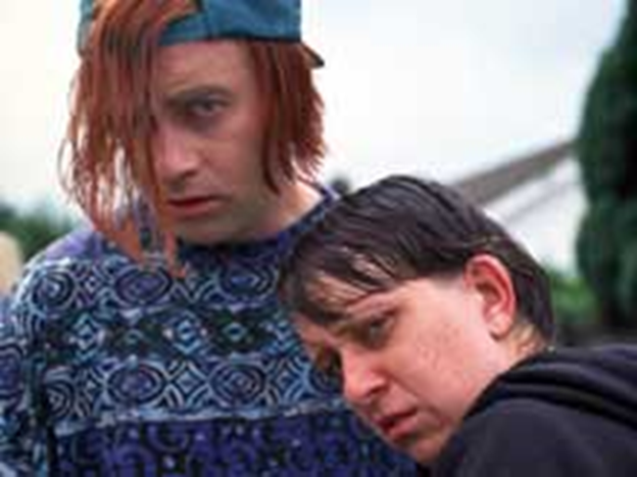

- Age: 19-45 years old
- Physical development – basically complete. Muscles are developed, strong and motor coordination is at its peak.
- Mental development – young adults seek additional education, choose careers and independence.
- Emotional development – Young adults are subjected to many emotional stresses related to career, marriage, family, etc.
- Social development – moving away from peer group, and adults tend to associate with others who have similar ambitions. Most find a mate and begin a family.

Middle Adulthood

- Age: 46-65 years of age
- Physical development – Hair greys and thins, skin wrinkles, muscle tone decreases, hearing loss, visual acuity losses, weight gain.
- Intellectual/cognitive development – can continue to increase. Confident decision makers and excellent at analyzing situations.

- Emotional development – can be a period of contentment and satisfaction.
- Social development -- Family relationships can decline as children begin lives of their own and parents die. Divorce rates are high. Friendships are with people with similar interests and lifestyles.

PIES development in Later Adulthood - 65 + years
- Age: 65 years of age and up
- Physical development – on the decline. Skin becomes dry and wrinkles; “age spots” appear. Hair thins, muscles lose tone and strength. Memory loss can occur and reasoning ability can diminish.

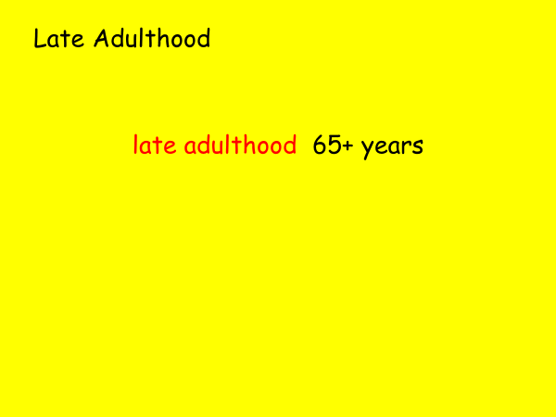

What do you know already?

Quick Quiz:

Approximately how many people 65+ years are there in the UK at present?
Approximately people in the UK are over 65 years old.

There were 5139753 males over 65+ in 2014.

How do you say 5139753?

There were 6267007 females over 65+ in 2014.

How do you say 6267007?
Add those two figures together to get the number of males and females over 65+ in the UK recorded in 2014.

5139753 +
6267007
---------------
11,406760
How do we say this number?

This number is set to double to around 19 million by 2050.

Approximately how many people 65+ years are there world-wide at present?
566,451,615
Out of a total of 7,130,013,761
in the world.
Task
What does an older person mean to you?

Think about stereo types.
Who do you know that is 65+ years?
Think about different cultures and beliefs?
How would this link in to work experience or employment?

Task - Tell me about these two people…

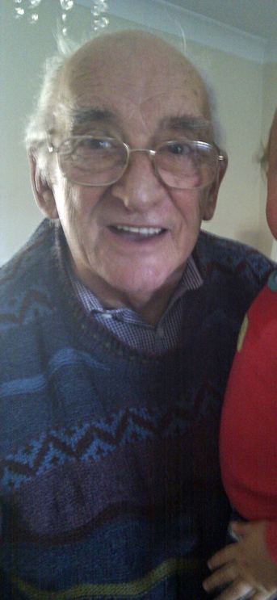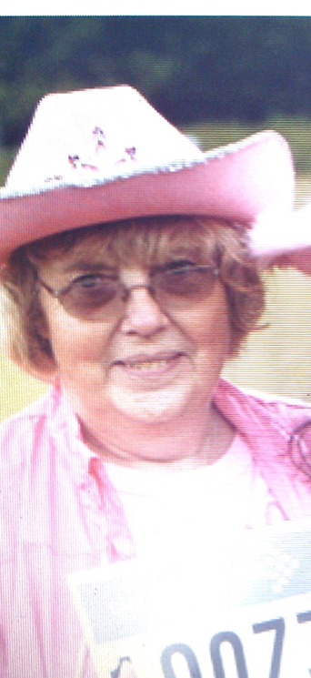

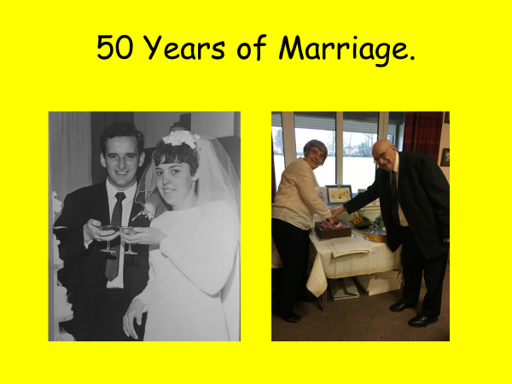
Physical Development
- The aging process progresses more once MOST people reach their 60’s.
- At some point older people may have to deal with some kind of disability as they will not be able to do some things that they did when they were younger.
- Getting older is definitely NOT an illness.
Watch the following youtube video.

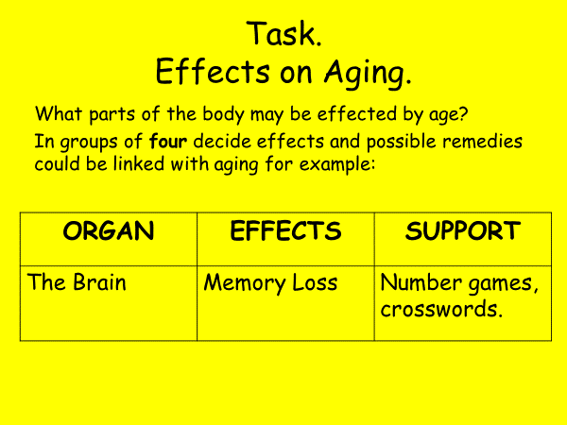
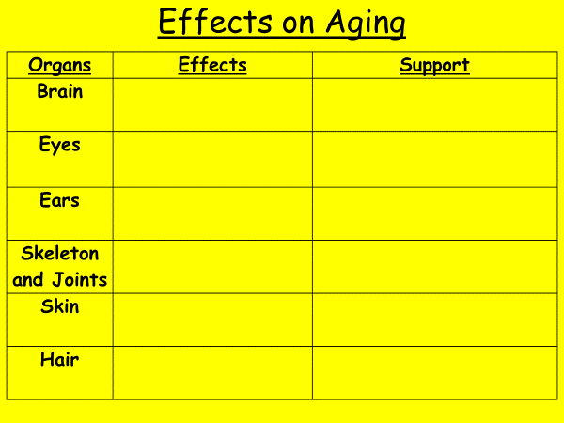

Intellectual Development
Some people contribute to society well after retirement age. Can you think of any?
Why do you think this is?

Mental stimulation is very important. Lots of older people learn new skills such as…what can you think of?

Languages
New games
Instruments
Have new hobbies.

Cultures and Beliefs
In some cultures, the ‘Wisdom of Old Age’ is very important.

Self-Discussion.

The brain shrinks slightly with age, and aging leads to a normal decline in cognitive function that may eventually bloom into dementias such as Alzheimer's disease.

Emotional and Social Development

Reflecting on 100 years

http://www.youtube.com/watch?v=gvcSXq-4Trs

How do the views of the people in the video make you feel?

End of Life Care
Physical changes are likely to occur when you're dying. These happen to most people during the terminal phase, whatever condition or illness they have. This can last hours or days.

Becoming drowsy
Individuals start to feel more tired and drowsy, and have less energy. Individuals may spend more time sleeping, and as time goes on slipping in and out of consciousness.

Not wanting to eat or drink

Not wanting to eat is common in patients who are dying. At this stage, it may also be difficult to swallow medicine.
Healthcare professionals often discuss alternative ways of taking medication with you if necessary.
Individuals may lose weight which may be upsetting for families.
As the body dies, it doesn’t digest food properly and you won't need to eat.
Carers may wet lips with water as eating and drinking becomes more difficult.

Changes in breathing

- Breathing may become less regular. You may develop Cheyne-Stokes breathing, when periods of shallow breathing alternate with periods of deeper, rapid breathing.
- The deep, rapid breathing may be followed by a pause before breathing begins again.
- Your breathing may also become noisier as a result of the build-up of mucus.
- The body naturally produces mucus in your breathing system, including the lungs and nasal passages. When you're healthy, this mucus is removed through coughing.
- When you're dying and no longer moving around, the mucus can build up and cause a rattling sound when you breathe.

Confusion and hallucinations

- Medicines or changes in the chemical balance of the brain can cause confusion or hallucinations.
- A hallucination is when you see or hear things that aren't there. When confused, recognition of where you are or the people you're with is inhibited.
- Some people may experience restlessness or seem to be in distress. For example, they may want to move about, even though they aren't able to get out of bed, or they may shout or lash out.
- This can be out of character and distressing for family and carers.
- The medical team can rule out or treat any underlying causes, such as pain, breathing problems or infection, or calm the person who is dying.
- If no underlying cause can be identified, there are medicines that can be used.

Cold hands and feet.
Feet and hands may feel cold as a result of changes in your circulation. Extra blankets over hands and feet can keep individuals warm.
Skin may look slightly blue because of a lack of oxygen in your blood. This is known as cyanosis.

Revision & Assessment

Refer to the Learner Handbook

