WFH Activity 1 – Crime Drama DVD Cover

Television crime dramas
These are fictional TV dramas that focus on crime solving, usually with a main detective or team of investigators, it could include programs like CSI, Sherlock, Midsomer Murders etc.
You need to create the DVD cover for a new TV crime drama called ‘Death Inspection’. Here’s a very basic example to give you some ideas – you can do it much better than this of course! The less white space the better.
Following the daring exploits of a team of forensic investigators, Death Inspection is the latest television crime drama from the BBC. Using clues and a range of forensic evidence, they won’t let any criminal rest until they’ve hunted them down.  DEATH INSPECTION  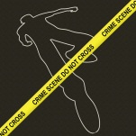  PG 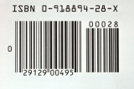 | PG | BBC  DEATH  INSPECTION  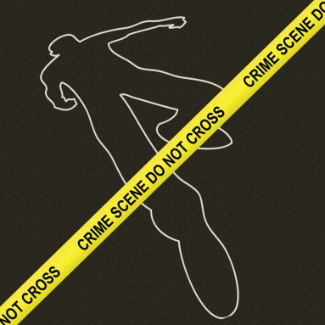  PG

Your DVD cover must include:
- A blurb on the back sleeve with two or three smaller pictures
- A barcode on the back sleeve
- A PG or 12 Certificate on front, back and side
- The title on the front and the side
- A main image on the front
- The institutional logo
Do this on Word, PPT or on paper!

